The Mercedes Sprinter Video Pursuit has been designed to allow the video and DIT department to become mobile. This means that not only does this remove the need to set up and strike the video village throughout the day, it also allows the video village to move instantly and if required to track alongside with the action- Driven by one of our precision tracking vehicle drivers.

This also allows wireless remote heads to be mounted on separate tracking vehicles to be operated from the video pursuit, whilst remaining close to the action sequence, preventing any wireless link drop out.

The Sprinter Video Pursuit can comfortably seat 8 crew members plus the driver. With seating, monitor mounting facilities and if required a 240V power supply via our mounted generator.

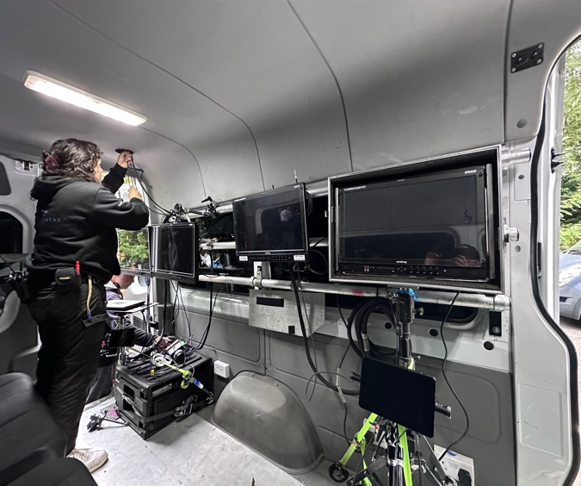
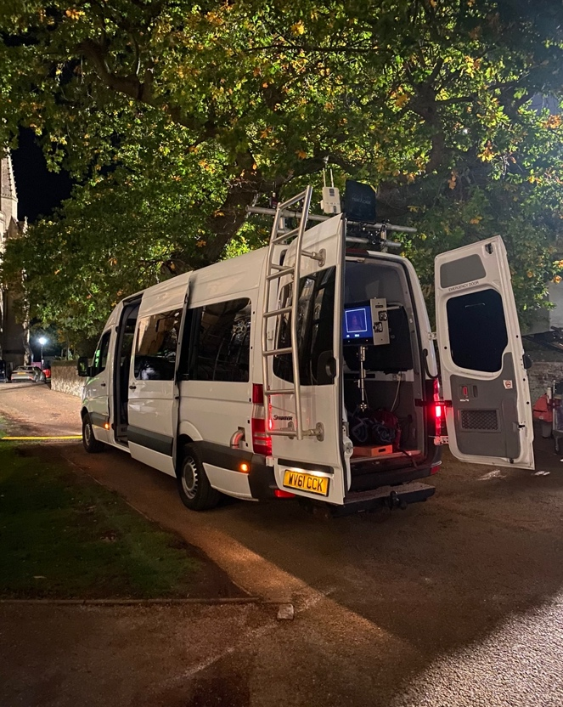

Standard Equipment | Optional Equipment
Seating & harnessing for 8 Crew | Additional Monitor Mountings
Roof Framework to Accommodate Antennas | 3K Generator
Monitor Brackets and Mounts | Scaffold Rigging Kit
Dimensions / Weights
Overall Length | 7m
Width | 2.1m
Height | 2.85m
Weight | 3500kg

