Low Loader Tracking Trailer No3

Low Loading No3 Tracking Trailer is towed by a 4×4 Vehicles. More Suited for Smaller Hero Cars.
The suspension is 100% air cushion and can be adjusted according to weight and ride comfort.
For crew comfort all of our Low Loaders have a weatherproof and safe crew compartment area with bench seating and safety harnesses for 6 crew members.
The Low Loader is Driven by one of our Precision Tracking Vehicle Drivers and if used as Tracking Vehicle and Low Loader Combination – 2 Man Crew is required for its operation and Rigging.

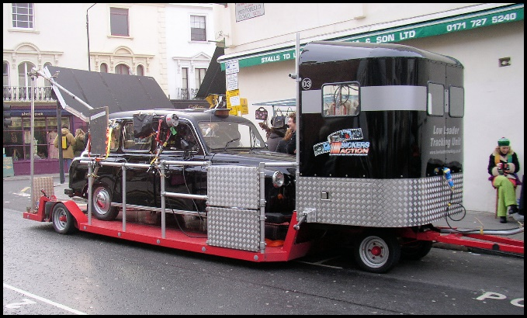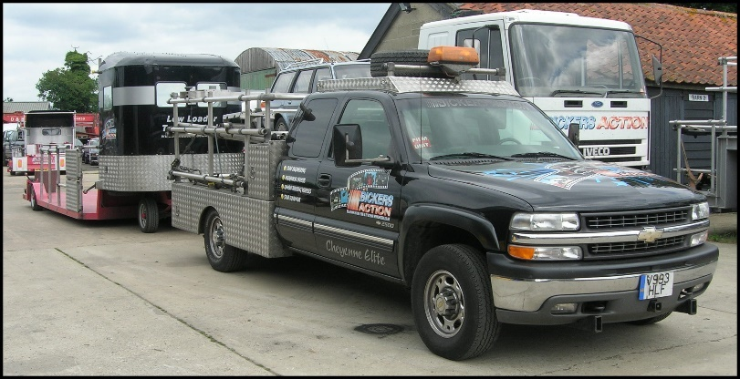

Standard Equipment | Optional Equipment
Safety Harnesses | Scaffold Tube and Fittings Rig
Lap belts in Crew Compartment | 5K Generator
Dimensions / Weights
Overall Length of Towing Vehicle and Trailer | 13m
Width of Low Loader | 2.55m
Height of Low Loader | 2.8m
Working Deck of Low Loader | 5.3m x 2.55m
Cheyenne Tracking Vehicle Length | 6.5m
Cheyenne Width | 2.2m
Cheyenne Working Deck | 2.4mx 2.2m
Gross Train Weight of Tow Vehicle and Trailer | 7000kg

